Six Months Industry Internship Report On

Trailblazing the Salesforce Frontier: Building Business Applications

At



Atorix IT Solutions, Pune Submitted by

Yash Bharat Hulle

Under the Guidance of

Prof. Sadashiv Badiger Mr. Abhijeet ManePatil (Internal Guide) (External Guide)



Department of Computer Science,

# G H Raisoni University, Amravati,

January, 2025

Academic Year 2024-25



# INDUSTRY INSTITUTE INTERACTION CELL CERTIFICATE

This is to certify that Mr. Yash Bharat Hulle has satisfactorily completed the six-month industry internship entitled Web Developer Intern at Atorix IT Solutions, Pune from 14 January 2025 to 14 July 2025. During the academic year 2024-25 for the partial fulfillment of B. Tech in Computer Science, G H Raisoni University, Amravati.

Prof. Sadashiv Badiger Mr. Abhijeet ManePatil (Internal Guide) (External Guide)

Dr. Simran Khiani Prof. Mahendra Sawane

(HoD of Comp Department) (Department III Coordinator)

Prof. Narsing Kadam

(Department III Coordinator)

Internal Examiner External Examiner

Dr. R. D. Kharadkar Director

GHRCEM Pune

# DECLARATION

I, Yash Bharat Hulle, hereby declare that this internship report, conducted at Atorix IT Solutions, Pune, from 13th January 2025 to 13th July 2025 during the academic year 2024-25, and submitted to G H Raisoni University, Amravati in partial fulfillment of the requirements for the award of the degree of B.Tech in Computer Science, is a record of the work carried out by me under the guidance of Prof. Mahendra Sawane.

All the information and data presented in this report are authentic and have been collected, analyzed, and documented during the course of my internship at Atorix IT Solutions. I further declare that this report has not been submitted, in part or full, for any other academic or professional purpose.

I sincerely acknowledge and express my gratitude to my mentor at PTC, whose valuable guidance and expertise significantly contributed to the successful completion of my internship. Any contributions or assistance from others during the internship period have been duly acknowledged within this report.

I fully understand that any misrepresentation or falsification of information in this report may result in actions as per academic or organizational policies.

with regards, Siddhant Zolage GHRUA

# ACKNOWLEDGEMENT

I would like to express my heartfelt gratitude to the Director of G.H. Raisoni College of Engineering and Management, Pune, for providing me with the opportunity to pursue my internship at Atorix IT Solutions. I am also deeply thankful to Mr. Sachin Umare, the Training and Placement Officer (TNP), and the HR team at PTC for facilitating this incredible opportunity.

I extend my sincere appreciation to all the individuals at Atorix IT Solutions who worked alongside me during this internship. Their patience, openness, and collaborative spirit created an enjoyable and enriching working environment. It is with immense gratitude that I acknowledge their contributions, which greatly enhanced my learning experience.

I am particularly grateful to my industry mentors at PTC, Abhijeet ManePatil Sir and my assigned team lead, whose consistent guidance and valuable insights supported me throughout the internship. The technical and professional skills I acquired under their mentorship will undoubtedly prove instrumental in my future endeavors. I also wish to thank the project leads and team members for their timely feedback and encouragement.

A special thanks to Prof. Simran Khiani, Head of the Computer Engineering Department, Prof. Mahendra Sawane, the Internship Coordinator, and Prof. Narsing Kadam for their unwavering support and advice, which were vital in the successful completion of my internship.

This experience has been a pivotal step in my professional growth, and I am deeply appreciative of everyone who contributed to its success.

with regards, Siddhant Zolage GHRUA

# ABSTRACT

Commencing my internship at Atorix IT Solutions, a leading provider of technology solutions specializing in Salesforce-based platforms, was an incredible opportunity to contribute to innovative projects and enhance my technical skills. From 08-07-2024 to 08-11-2024, I actively participated in development processes aimed at optimizing Salesforce functionalities, improving user experiences, and supporting PTC’s mission of driving digital transformation and innovation.

## Objectives:

* Skill Development: Acquiring practical skills in Salesforce development within a collaborative and professional environment.
* Contribution: Actively contributing to the enhancement of Salesforce functionalities and solutions for business process optimization.
* Industry Understanding: Gaining insights into the challenges and strategies within the cloud-based CRM domain and digital transformation initiatives.

## Vision:

Atorix IT Solutions envisions empowering businesses through advanced digital solutions that drive innovation and streamline product lifecycle management, customer relationship management, and operational processes.

Addressing Industry Challenges:

Atorix IT Solutions was established to provide cutting-edge solutions to businesses, focusing on:

* Scalability: Delivering robust and scalable software solutions tailored to diverse industries.
* Efficiency: Streamlining business processes through automation and integration of advanced technologies like IoT and AR.
* User Experience: Enhancing user satisfaction with intuitive and responsive platforms.

This introduction sets the foundation for the subsequent sections, where I will elaborate on my role, the technical aspects of Salesforce development during the internship, and the projects that aligned with Atorix IT Solutions’s mission and vision.

**INDEX**



**INDEX PAGE**

|  |  |  |
| --- | --- | --- |
| **Sr.**  **No.** | **Contents** | **Page No** |
| **1** | **Introduction of Industry** | **1** |
| **2** | **Organization Structure** | **2** |
| **3** | **Introduction of Product/Service/Software** | **3** |
| **4** | **Introduction of work assigned** | **5** |
| **5** | **Detailed Study** | **6** |
| **6** | **Project** | **10** |
| **7** | **Results and Analysis** | **20** |
| **8** | **Challenges** | **21** |
| **9** | **Skills Required** | **22** |
| **10** | **Conclusion** | **23** |
| **11** | **Participation of External and Internal Guide** | **24** |
| **12** | **Images** | **25** |
| **13** | **Internship Offer Letter** | **26** |
| **14** | **Industry Feedback Form** | **28** |
| **15** | **NPTEL Certificate** | **29** |

1. **INTRODUCTION**

Atorix IT Solutions is a global leader in digital transformation solutions that empower businesses to design, manufacture, operate, and service products more effectively. Founded in 1985 and headquartered in Boston, Massachusetts, PTC has established itself as a pioneer in technologies that drive innovation and enhance operational efficiency. The company's software portfolio includes cutting-edge solutions in Product Lifecycle Management (PLM), Computer-Aided Design (CAD), Augmented Reality (AR), Industrial Internet of Things (IoT), and Service Lifecycle Management (SLM).

PTC's core mission is to help companies unlock their potential by delivering tools that integrate the physical and digital worlds. Their flagship platforms like ThingWorx, Windchill, and Vuforia enable industries such as manufacturing, automotive, aerospace, and life sciences to accelerate product development, streamline operations, and improve customer experiences.

As a Salesforce team intern at PTC, the focus lies on optimizing service operations and leveraging cloud platforms to enhance digital thread capabilities, aligning with PTC's vision to provide transformative solutions for a connected and sustainable future.

## Core Mission:

* Innovation: At PTC, we believe in harnessing the power of technology to drive innovation and deliver exceptional value to our customers.
* Customer Success: Our goal is to help businesses achieve success through our comprehensive suite of software solutions and services.
* Education and Training: PTC is committed to bridging the gap between theoretical knowledge and practical skills by providing hands-on internships and training programs. Interns have the opportunity to work alongside experienced professionals, gaining valuable experience and expertise.

## Key Products and Services:

* CAD Software: PTC Creo, enabling detailed and precise product design.
* Product Lifecycle Management (PLM): PTC Windchill, streamlining the product development process.
* Internet of Things (IoT): PTC ThingWorx, connecting devices and systems for enhanced operational efficiency.
* Augmented Reality (AR): PTC Vuforia, delivering immersive experiences for training and product visualization.

Global Presence:

* Office: Weikfield, D building, Viman Nagar, Pune.
* Headquarters: Boston, Massachusetts, USA

# ORGANIZATION STRUCTURE

Atorix IT Solutions operates with a globally integrated structure designed to foster innovation and efficiency across its diverse business functions. Its organizational framework is structured to enable collaboration, streamline operations, and deliver impactful solutions to customers worldwide. Key components of PTC's structure include:

1. Leadership Team
   * Executive Management: Led by a Chief Executive Officer (CEO) and supported by a team of senior executives responsible for defining the company’s strategic direction and overseeing its global operations.
   * Regional Leadership: Facilitates operations in key markets, ensuring the alignment of regional strategies with global objectives.
2. Business Units
   * Digital Transformation Solutions: Focused on Product Lifecycle Management (PLM), Internet of Things (IoT), and Augmented Reality (AR) solutions, enabling businesses to connect to the physical and digital worlds.
   * Customer Success Division: Dedicated to ensuring client satisfaction through comprehensive training, consulting, and support services.
3. Research & Development
   * Houses teams of engineers, developers, and designers who innovate across platforms like ThingWorx, Windchill, and Vuforia, ensuring continuous enhancement of PTC’s product offerings.
4. Operations & Support
   * Handles supply chain management, client onboarding, and operational logistics, ensuring smooth delivery and deployment of PTC's solutions to customers.
5. Marketing & Sales
   * Focuses on brand positioning, customer engagement, and expanding the reach of PTC’s solutions in various industries through strategic campaigns.
6. Salesforce Team
   * Plays a vital role in managing customer relationships and optimizing service delivery. Teams are responsible for leveraging Salesforce tools to streamline processes and improve customer engagement across all business lines.

# INTRODUCTION OF PRODUCT/SERVICE/SOFTWARE

Atorix IT Solutions, where I pursued my internship, is a global leader in digital transformation solutions, empowering industries with cutting-edge technology to innovate and operate efficiently. Headquartered in Boston, Massachusetts, and with a strong presence in India, PTC specializes in offering tools that bridge the gap between the physical and digital worlds.

## Key Offerings:

* 1. Product Lifecycle Management (PLM): Tools like Windchill help organizations manage product data and streamline development processes.
  2. IoT Solutions: The ThingWorx platform enables businesses to connect, monitor, and optimize their physical assets.
  3. Augmented Reality (AR): Solutions like Vuforia empower users to visualize and interact with digital content in real-world environments.
  4. CAD Software: PTC’s Creo platform supports advanced design and engineering processes.

## Mission and Vision:

PTC aims to help companies achieve their digital transformation goals, enhancing productivity, efficiency, and sustainability in industries such as manufacturing, aerospace, healthcare, and more. The company’s vision revolves around enabling innovation and operational excellence through a combination of software, services, and a forward-thinking approach.

## Services Provided:

1. Digital Solutions: Comprehensive platforms for product design, manufacturing, and IoT applications.
2. Customer Support & Success: Tailored training, consultations, and support for seamless adoption of PTC tools.
3. Salesforce Integration Services: Optimizing customer relationship management through Salesforce’s capabilities.

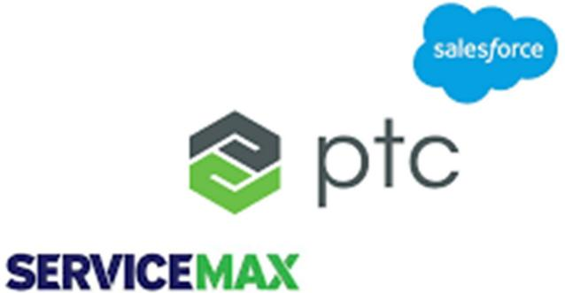

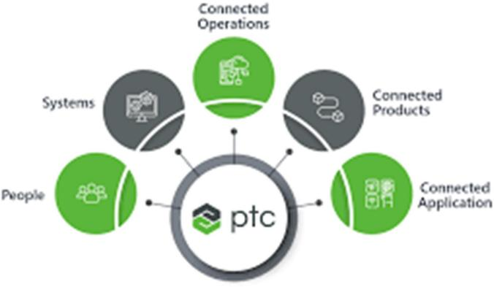

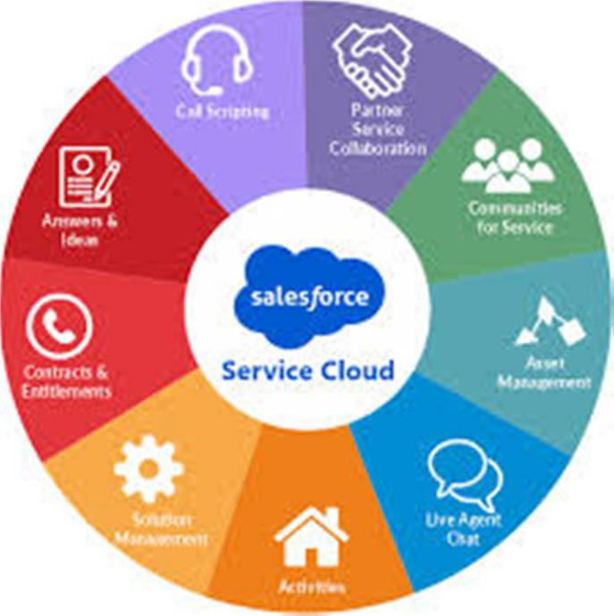

# INTRODUCTION OF WORK ASSIGNED

During my internship, I was involved in several key projects that allowed me to apply my Salesforce knowledge while developing practical skills. My contributions included the following:

* Salesforce Administration: I focused on user and profile management, where I learned to set up user roles and permissions effectively. This involved ensuring data integrity and security, allowing users to access the necessary information while safeguarding sensitive data.
* Development Modules: I worked extensively with Apex triggers and test classes, honing my programming skills by developing Visualforce pages. This experience allowed me to explore various use cases, enhancing my understanding of Salesforce’s customization capabilities.
* Automation Processes: I gained insights into Salesforce’s automation features, implementing processes such as workflow rules and process builders to streamline operations.
* Project Participation: I collaborated on a significant project aimed at optimizing Salesforce functionalities for a client. This role involved engaging in both hands-on development and learning modules, ensuring that I could contribute effectively while expanding my skill set.
* Knowledge Transfer and Training • Service Cloud Fundamentals: I attended several sessions focused on Service Cloud basics, understanding how the module supports case management, and enhances customer service interactions within Salesforce. I completed Trailhead trailmixes on Service Cloud to deepen my practical understanding.
* Testing Apex Classes and Visualforce Pages • I participated in code review and testing activities for Apex classes and Visualforce pages. Testing these components was essential to ensure system reliability and optimal performance. • My responsibilities included running test scenarios, identifying code inefficiencies, and documenting testing outcomes
* Documentation and Support: I also contributed to documenting processes and user guides, which were essential for training end-users and ensuring smooth transitions during software updates.

# DETAILED STUDY

## Objective:

The main goal was to collaborate with the Salesforce development team to enhance CRM functionalities and improve overall system performance for PTC Software. My role primarily focused on assisting with the integration of new features, optimizing existing ones, and ensuring seamless interactions between different components of the platform.

## Activities:

* Collaborative Development Sessions: I actively participated in sessions with the development team to understand the requirements and goals of specific features. These meetings allowed me to gather insights into the broader objectives of the Salesforce platform and how we could deliver an effective and user-friendly experience for both internal and external users.
* Apex Class and Visualforce Page Testing: I was involved in the testing phase of Apex classes and Visualforce pages, which are core components of Salesforce custom development. My responsibilities included validating the functionality, performance, and user experience to ensure that they met both technical and business requirements.
* Design and Functional Alignment: Regular collaborative sessions with team members helped align the development efforts with the overall design principles of the Salesforce platform. This ensured that the user interface (UI) was not only functional but also aligned with the company's visual standards and usability best practices.
* Feedback Integration for System Optimization: Throughout the internship, I provided technical feedback on the features developed by the team, ensuring that the final implementation was efficient and scalable. This feedback was especially valuable in improving the integration between Salesforce and other business systems.
* Salesforce Customization and Formula Fields: I worked on creating custom functions and formula fields to enhance existing methods within the Salesforce system. This task helped to improve workflows and automate processes, leading to better efficiency in the use of Salesforce by internal teams.
* Documentation and Knowledge Sharing: In addition to hands-on development, I contributed to the documentation of the work completed, which included explaining the functionalities of the newly implemented features. I also participated in knowledge-sharing sessions, helping other interns and team members understand the technical aspects of Salesforce development.

## Tools and Technologies Used:

* Salesforce Platform: Apex, Visualforce, Lightning Web Components (LWC)
* Trailhead (Salesforce Training): Throughout my internship, I completed various Salesforce training modules, which helped in enhancing my knowledge of the platform.

## Project tasks completed:

* + 1. Recruiter Application Home Page Layout:

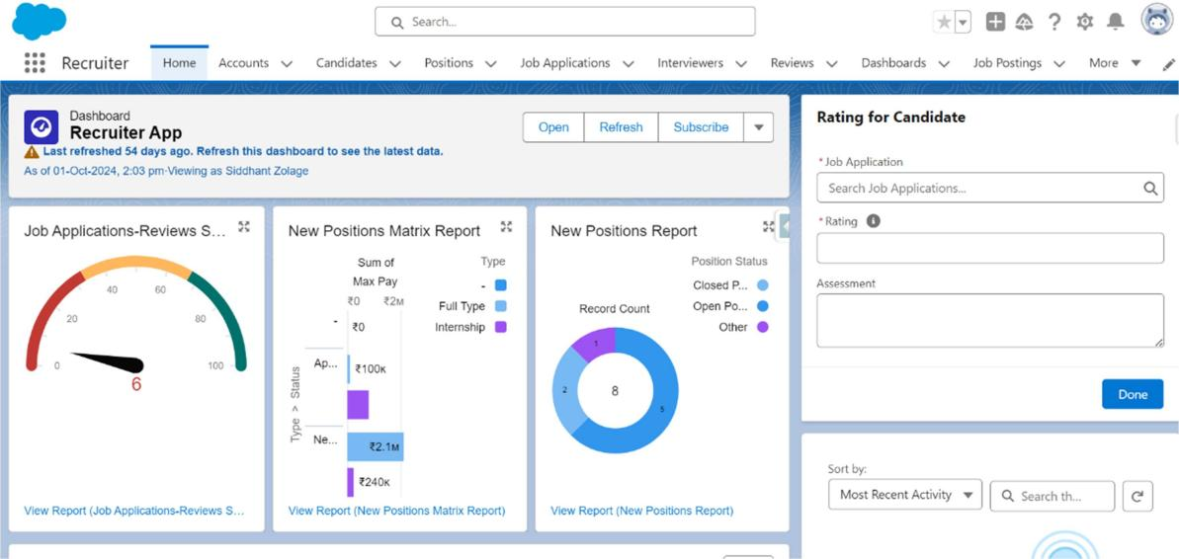

* + 1. Candidate Page UI:

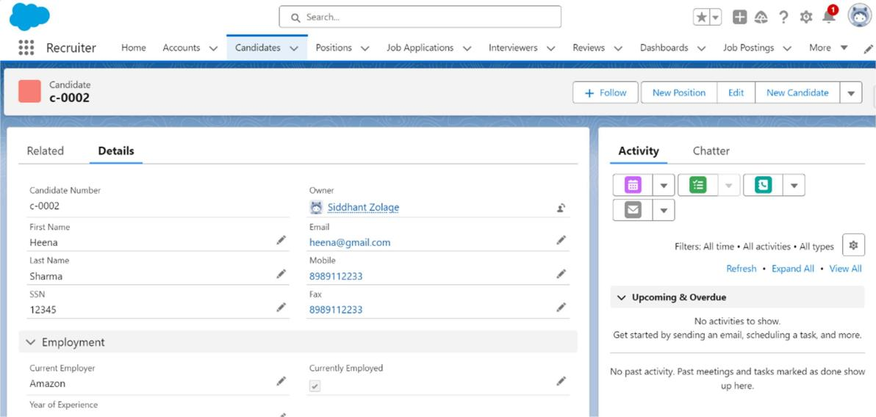

* + 1. User Level Permission:

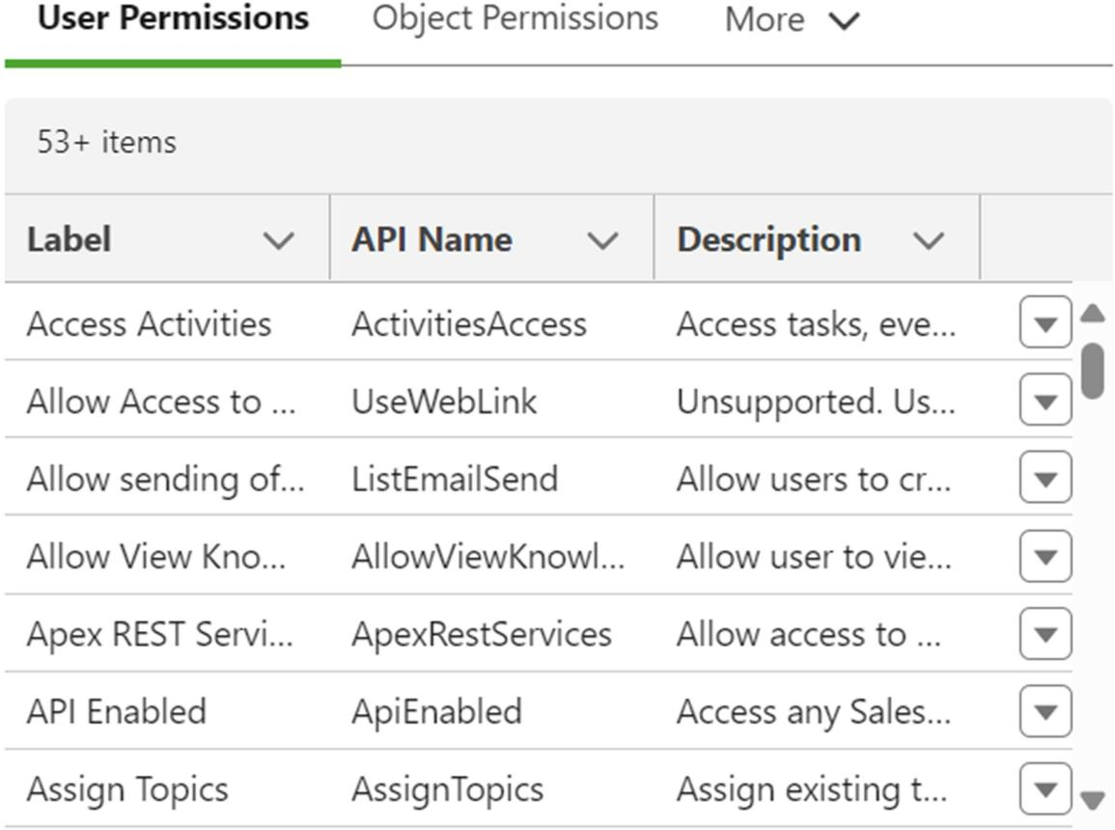

* + 1. Record Flow Diagram:

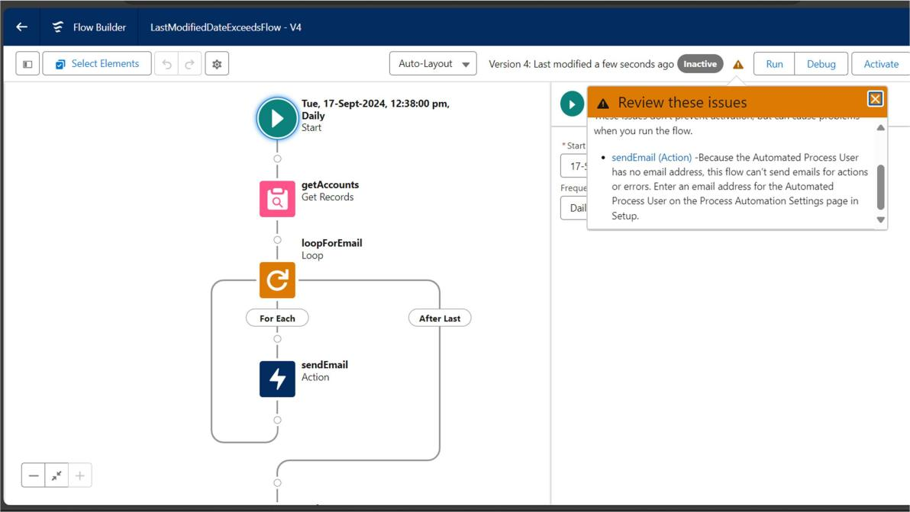

* + 1. Screen flow diagram:

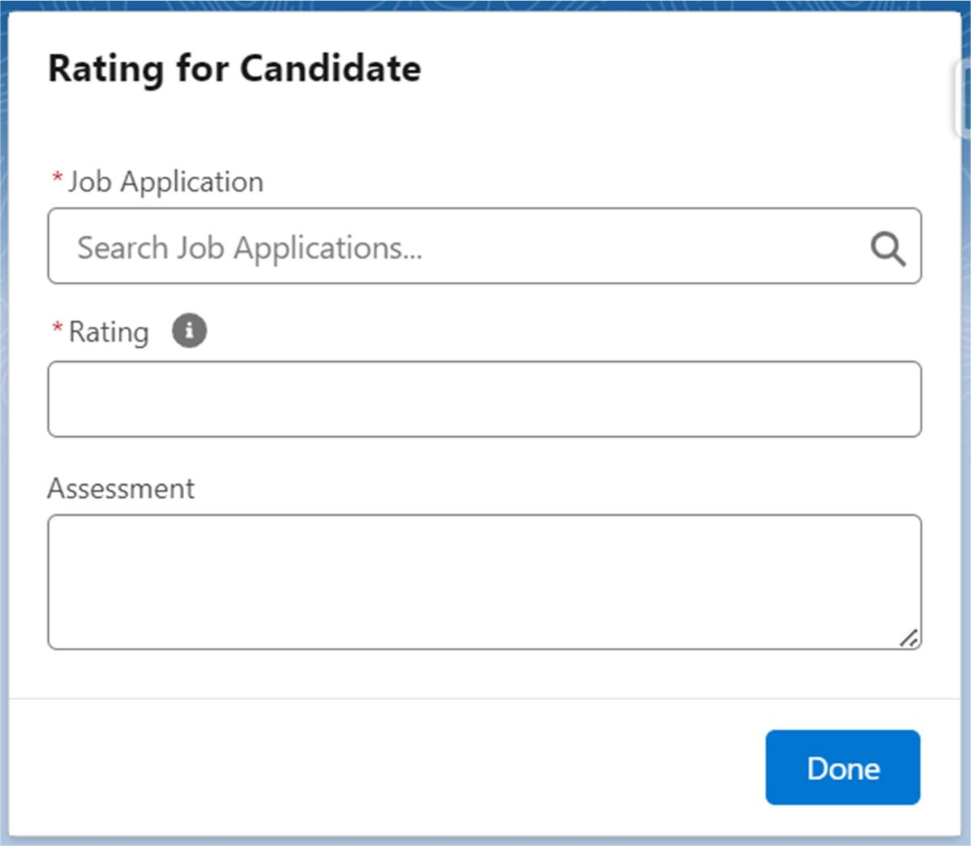

# PROJECT:

* 1. **SALESFORCE APPLICATION FOR STREAMLINING RECRUITMENT PROCESS**

During my internship at Atorix IT Solutions, one of the significant tasks I completed was developing a comprehensive Salesforce application designed to streamline the recruitment process. This application was created with the aim of automating various recruitment stages, providing a centralized platform for job postings, candidate management, and the entire hiring workflow. The app was developed using Salesforce’s robust features, including custom objects, relationships, flows, and automation tools.

## Key Features and Components:

* Custom Objects and Relationships:

The application was structured around several key custom objects that represent core recruitment activities, such as:

* + Job Position: Stores the details of the open positions within the organization.
  + Job Application: Captures information about candidates applying for the job.
  + Candidate: Represents individual candidates, including personal details and qualifications.
  + Review: Contains feedback and assessments from the hiring team about each candidate.
  + Job Posting: Facilitates posting job openings on the company website.
  + Employee Website: A platform where job seekers can browse and apply for available positions.
* Fields and Formulas:

I designed custom fields and formula fields to capture and calculate essential data, such as candidate eligibility, job posting status, and review scores. Formula fields were used to calculate metrics like "Time to Hire" and "Application Status," ensuring recruiters had real-time insights into the recruitment pipeline.

* Role Hierarchy, Profiles, and Permission Sets:

The app was structured to ensure appropriate access control and security. The role hierarchy was set up to provide recruiters, hiring managers, and HR personnel with the right access to records based on their positions.

Profiles were configured to define the level of access and actions permitted within the system. For example, recruiters had access to job applications and candidate records, while hiring managers had additional permissions to review and approve candidates.

* Approval Processes:

I implemented approval processes for the recruitment workflow, particularly for reviewing and finalizing candidate applications. When a hiring manager reviewed a candidate's profile, they could submit the application for approval by HR. This approval process ensured that all candidates went through a standardized review before being shortlisted.

* Flows:

Screen Flows were used to guide recruiters through structured steps when reviewing candidates or posting jobs. For instance, when a recruiter clicks on a job application, they are prompted with a screen flow that guides them through candidate evaluation steps, from initial review to final decision.

Additionally, record-triggered flows were set up to automate tasks like sending notifications to candidates when their application status changes or creating follow-up tasks for recruiters.

* Automation and Efficiency:

Using Salesforce’s automation tools, I built several processes and workflows to trigger actions based on specific conditions, such as notifying hiring managers when a new application is submitted or automatically updating candidate statuses once an interview is scheduled. This automation minimized manual efforts, improved operational efficiency, and ensured timely communication.

* User Interface:

I also focused on making the user interface intuitive and easy to navigate. By leveraging Salesforce Lightning components and custom pages, the app provided a seamless experience for recruiters and managers. The application’s user interface was designed to ensure that users could easily access relevant information, whether they were reviewing job applications or posting new positions.

* Impact and Results:

This application has had a significant impact on the recruitment process within the organization. By centralizing all recruitment-related data and automating key tasks, the app has reduced administrative overhead, improved candidate tracking, and accelerated the hiring timeline. The intuitive interface and automation tools provided a smooth and efficient workflow for recruiters and hiring managers alike.

The app not only helped streamline the recruitment process but also provided valuable insights through reports and dashboards. These tools allowed HR teams to track key metrics, such as the time-to-fill for positions and the success rate of job postings, enabling better decision-making and continuous improvement of the hiring process.

## Tools and Technologies Used:

* Salesforce Platform: For building the custom application and objects.
* Apex (for logic and automation)
* Visualforce (for custom user interfaces)
* Salesforce Flow Builder (for creating screen flows and automation)
* Reports and Dashboards (for tracking recruitment metrics).

This project was a significant learning experience that deepened my understanding of Salesforce development, workflow automation, and the recruitment process. It also gave me hands-on experience in building full-fledged applications that integrate business needs with technology solutions.

* + 1. Recruiter Application Block Diagram:

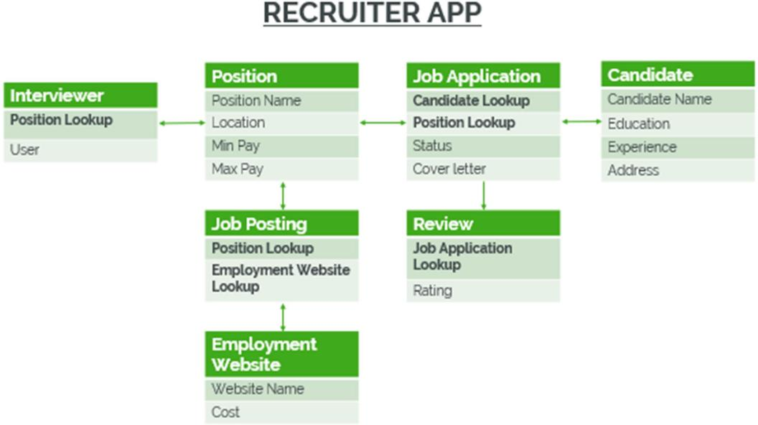

* + 1. Recruiter Application Home Page:

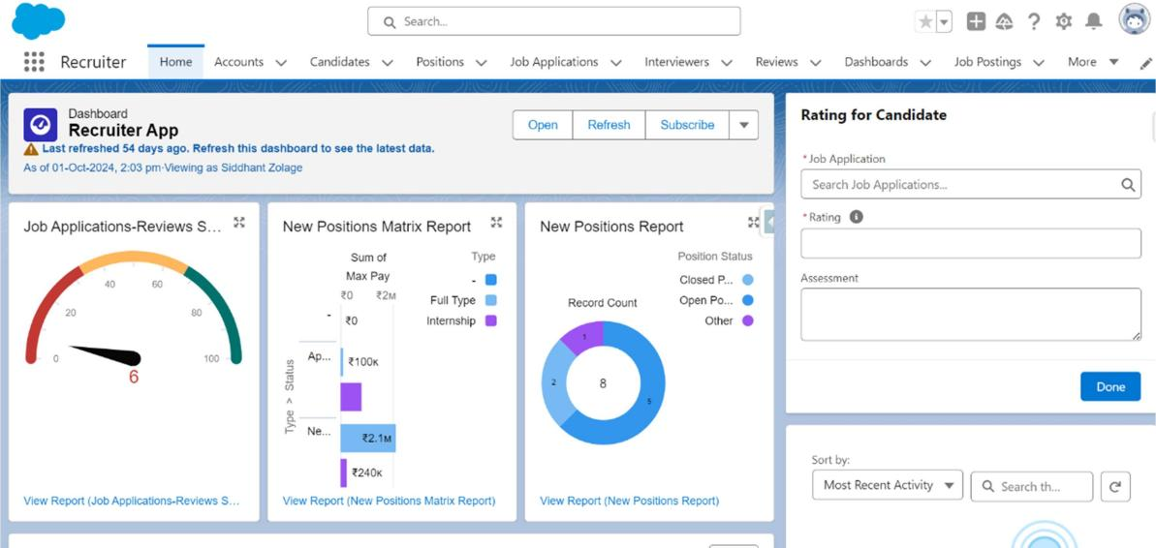

* + 1. Candidate Page:

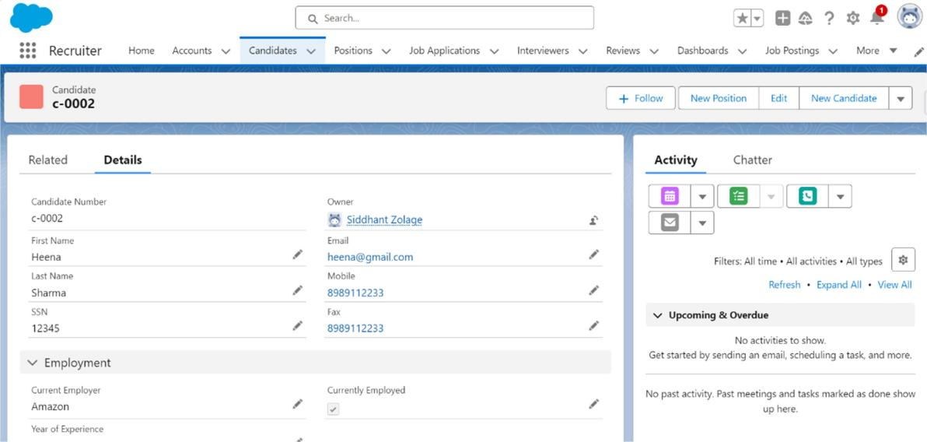

* + 1. Job Application Page:

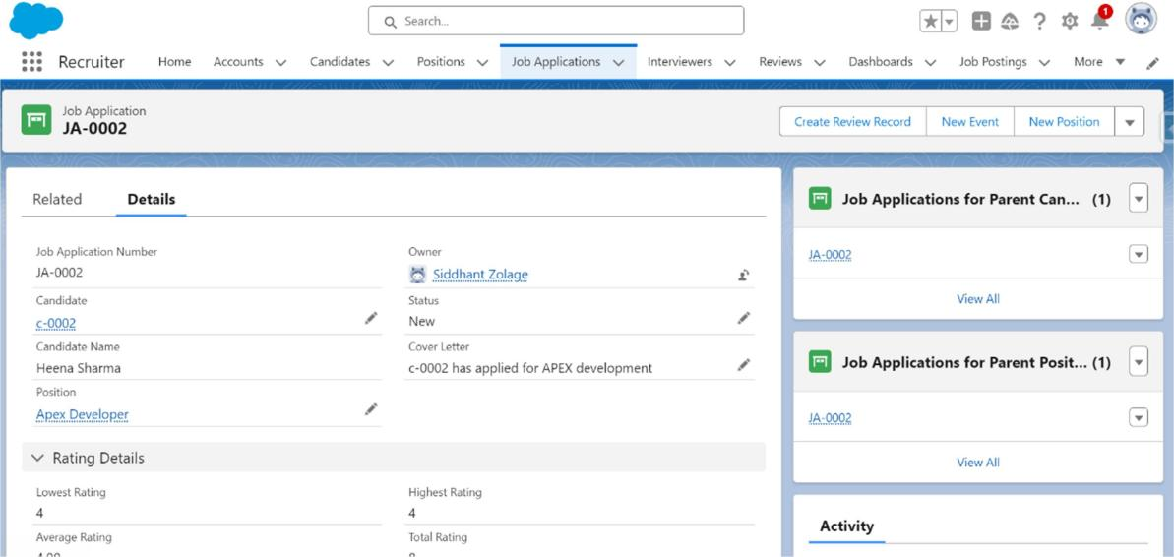

* + 1. Screen flow for Candidate Rating:

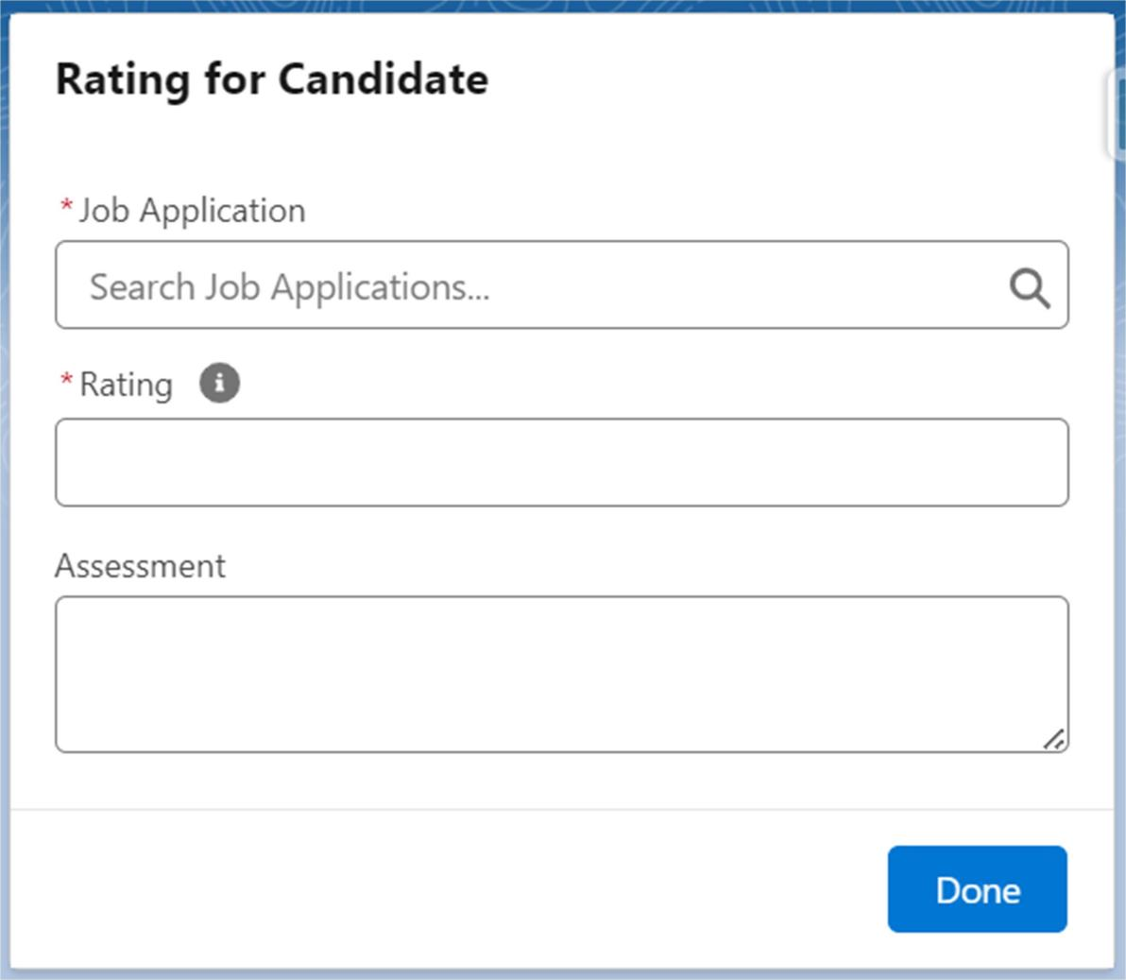

* + 1. Object Summary:

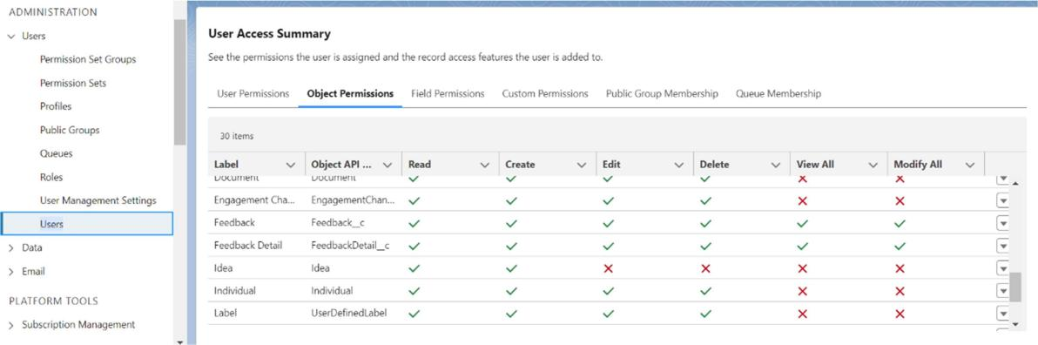

* + 1. Dashboard for Job application and new positions:

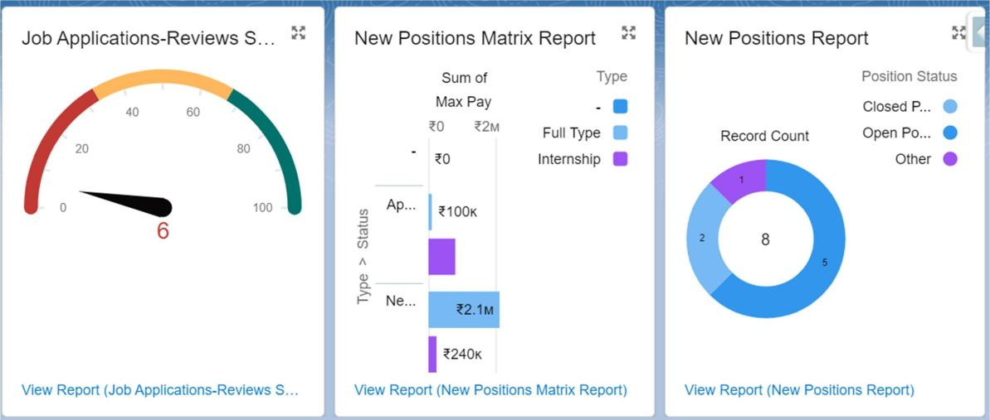

* + 1. Chart for Job application and new positions:

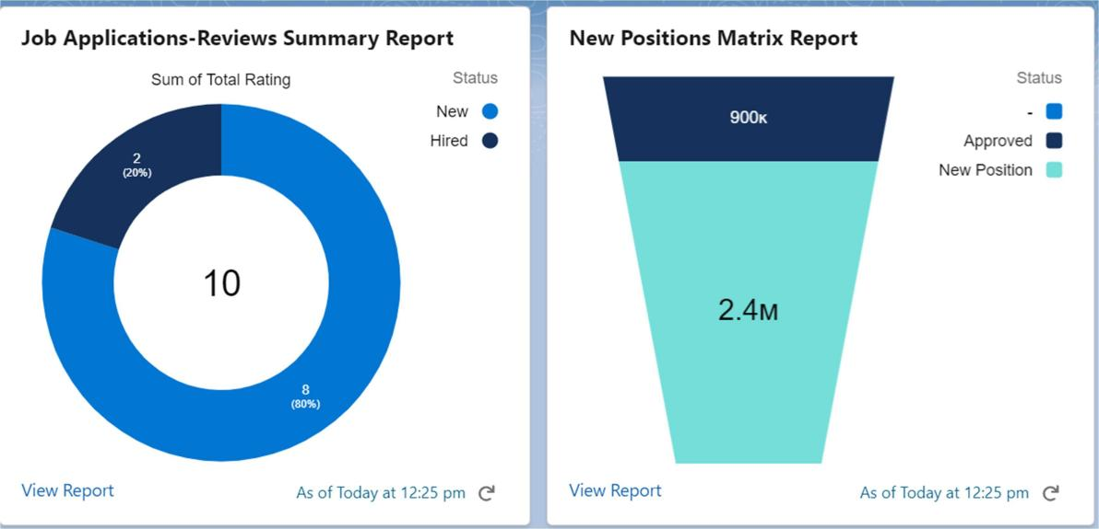

# PROJECT

**6.2. FEEDBACK MANAGEMENT SYSTEM - FEEDBOOST APP**

During my internship, I also developed the **FeedBoost App**, a comprehensive Feedback Management System aimed at streamlining the collection, management, and reporting of feedback for various services and orders. The project provided valuable hands-on experience with Salesforce, particularly in managing custom objects, data relationships, and automation processes, and it successfully improved the efficiency of feedback management for the target organization.

The FeedBoost app features several key custom objects such as **Service Orders**, **Service Categories**, **Reports**, and **Feedback Entries**. The system automates the collection of feedback for each service rendered and order completed, enabling the organization to monitor service quality, address concerns, and take actionable insights to improve their offerings. By creating this application, I was able to demonstrate how Salesforce can be leveraged to address real-world business needs through process automation, custom reporting, and seamless data management.

## Key functionalities of the app include:

1. Service Order Management: Custom object for tracking each service order and the associated feedback. This ensures that feedback is accurately tied to a specific order, streamlining the review process.
2. Service Category Organization: Categorizing services allows for the aggregation of feedback and the identification of trends across different service types, which aids in making data-driven decisions.
3. Feedback Collection: Integrated feedback forms are used to gather user responses regarding the quality of the services rendered. This data is then stored in Salesforce, associated with the respective service orders and service categories.
4. Reporting and Analytics: Reports and dashboards are dynamically created to visualize service quality and customer satisfaction across various service categories. These insights are critical for management to assess performance and identify areas for improvement.
5. Automation: The app utilizes **Salesforce Flows** to automate several processes such as sending feedback reminders to customers, escalating negative feedback to the appropriate service teams, and generating feedback summary reports.
6. Approval Processes: The app also includes approval workflows to ensure that all feedback, particularly negative or critical reviews, are reviewed by the designated managers before any actions are taken.

## Key Technologies and Skills Acquired:

1. Salesforce Custom Objects and Data Relationships
2. Salesforce Flows for Process Automation
3. Apex Triggers for Enhanced Functionality
4. Feedback Collection and Survey Integration
5. Reports and Dashboards for Business Insights
6. Approval Processes and Automated Alerts
7. UI/UX Design Principles in Salesforce
8. Problem-Solving and Debugging Techniques

Through the development of the FeedBoost App, I not only deepened my technical expertise in Salesforce development but also improved my ability to build applications that solve practical business problems. This project further reinforced the value of user-centric design and the importance of ensuring that the end users' needs are always met through seamless workflows and automation.

The project also provided an excellent learning opportunity for collaboration within a cross-functional team, where I worked closely with other developers, business analysts, and stakeholders to ensure that the application addressed all relevant business requirements.

Ultimately, the FeedBoost App enhanced the service feedback collection and reporting process, significantly improving operational efficiency and empowering businesses to act on customer feedback in real time.

* + 1. Feedboost Application Home Page:

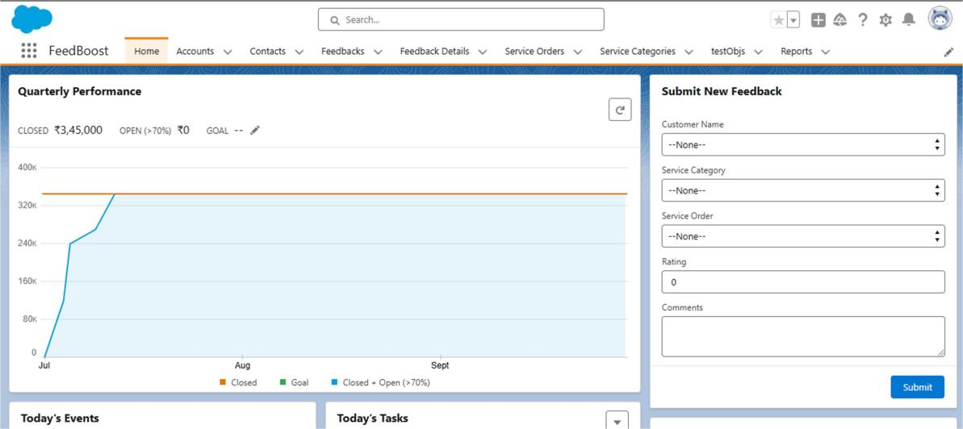

* + 1. Feedback Page UI:

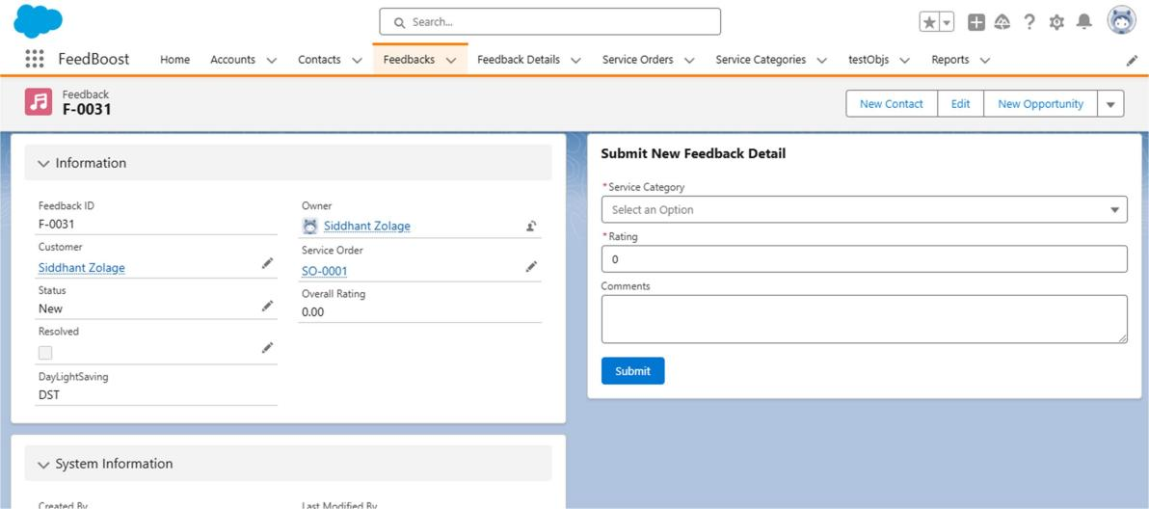

* + 1. Service Categories Object:

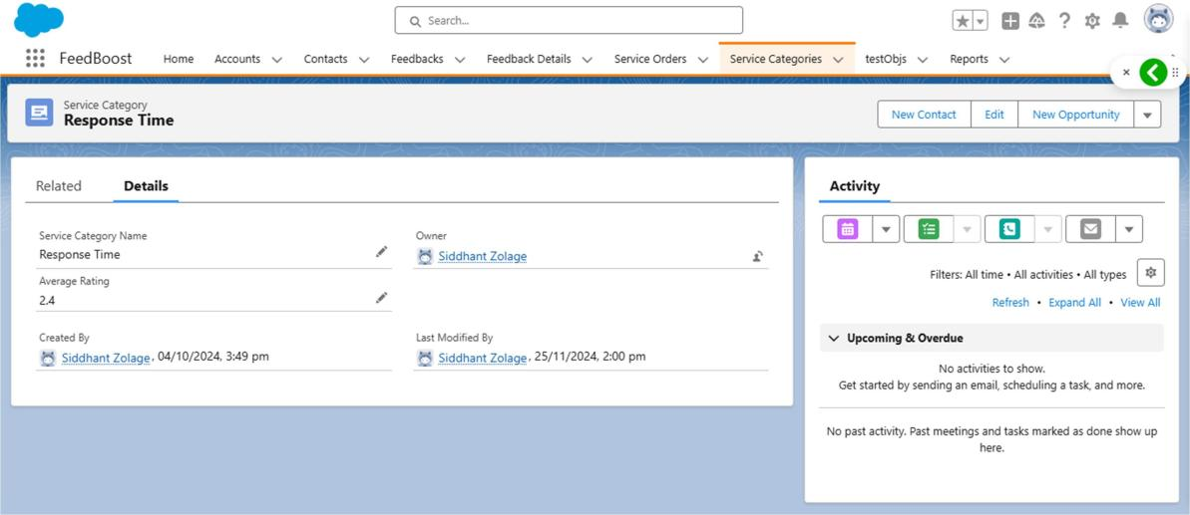

* + 1. Screen flow for creating new feedback:

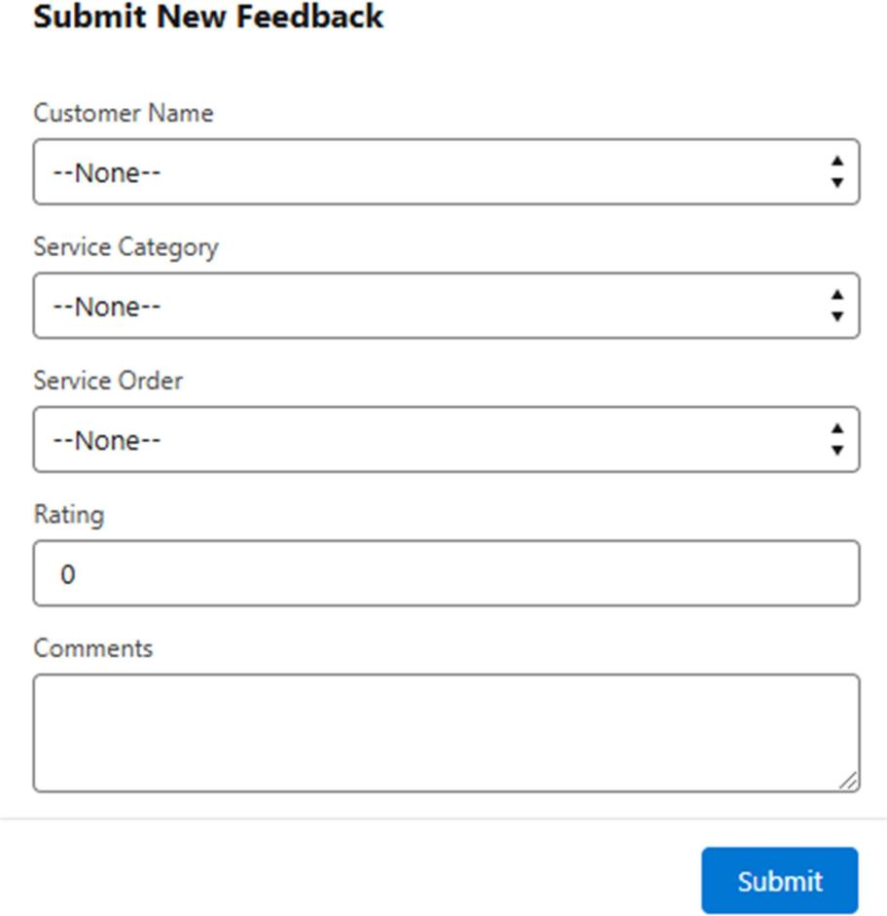

# RESULT AND ANALYSIS

Throughout the internship, I not only honed my technical abilities but also developed important soft skills such as effective communication, time management, and collaborative teamwork. Despite the challenges of a hybrid work model, the overall experience was rewarding and insightful. My engagement with cross- functional teams, especially the back-end developers and HR staff, was essential in building the application for streamlining the recruitment process.

The successful implementation of key features such as custom objects (Job Position, Candidate, Job Application, etc.), relationship mappings, formula fields, and automated workflows highlights my proficiency in Salesforce development. Additionally, the seamless integration of Google Sign-In for secure user authentication and the creation of an intuitive user interface emphasized my ability to marry functionality with user experience.

Working in a real-world Salesforce environment further deepened my understanding of business requirements and the importance of adaptability in the face of evolving needs. This project solidified my expertise in Salesforce Custom Objects, Flows, Apex, and Process Automation, which were crucial to the app's success. Furthermore, my exposure to creating custom dashboards and reports allowed me to offer HR personnel actionable insights into the recruitment process.

In addition to technical growth, the internship enhanced my professional conduct, particularly in office protocol, collaboration, and communication. The experience of presenting ideas to stakeholders, gathering feedback, and continuously iterating on features helped improve both my technical and interpersonal skills. These skills will undoubtedly benefit me as I continue in my career.

## Key Technologies and Skills Acquired:

* Salesforce (Custom Objects, Flows, Apex)
* Salesforce Lightning Experience
* Apex Triggers and Automation
* Google Sign-In Integration
* Reports and Dashboards
* UI/UX Design in Salesforce
* Process Automation
* Problem-Solving and Debugging

This project not only gave me hands-on experience in full-fledged Salesforce application development but also helped me develop a comprehensive skill set. The ability to solve business problems with technology and work efficiently with a team has made this internship a valuable milestone in my professional journey.

# CHALLENGES

During my internship at Atorix IT Solutions, I faced several challenges that provided valuable learning experiences and opportunities for personal and professional growth.

* Remote Internship Challenges: My internship was conducted in a hybrid mode, which presented some difficulties. Communicating effectively through calls and virtual meetings, while maintaining a clear understanding of concepts, was a challenge. This required more effort in terms of independent research and clarification, as the absence of face-to-face interactions sometimes made it harder to grasp technical details quickly.
* Adapting to the Salesforce Environment: One of the primary challenges was adapting to the Salesforce platform's complexity and its dynamic nature. Learning to work with Salesforce's various components like Apex, Visualforce, and Lightning Web Components (LWC) required considerable time and effort. The rapidly evolving nature of Salesforce development meant that I had to stay updated on the latest features and best practices, which was an ongoing process throughout the internship.
* Technical Challenges with Code Debugging: Debugging Apex classes and Visualforce pages posed some technical difficulties. Compatibility issues with different browsers and performance optimization were common challenges. I had to adopt a systematic approach to troubleshoot and solve these issues, utilizing Salesforce's debug logs and testing tools effectively.
* Time Management: Juggling between internship tasks, academic responsibilities, and personal life proved to be challenging at times. The workload from college and internship sometimes felt overwhelming, requiring effective time management to meet deadlines for both academic assignments and work-related tasks.
* Collaborative Work and Communication: Clear communication with team members was essential, especially when working on complex Salesforce solutions. At times, there were challenges in aligning with different team members' working styles or understanding the full scope of certain features. This was resolved through constant feedback and collaborative problem- solving.

Despite these challenges, each experience provided me with valuable insights and enhanced my skill set. The continuous learning and problem-solving allowed me to improve my technical and professional abilities, making the overall internship experience rewarding and enriching.

# SKILLS USED

## Salesforce Development:

* + Apex Programming: Gained proficiency in using Apex, Salesforce's proprietary programming language, to write custom business logic, triggers, and controllers.
  + Visualforce Pages: Developed and customized Visualforce pages, creating user interfaces that integrate seamlessly with Salesforce's backend data.
  + Lightning Web Components (LWC): Gained experience in building modern web interfaces using Lightning Web Components, improving user experience by leveraging Salesforce's latest front-end framework.

## Service Cloud:

* + Service Cloud Features: Applied knowledge of Salesforce Service Cloud to enhance customer service processes. Contributed to tasks involving case management, knowledge management, and service automation tools.
  + Automated Workflows: Assisted in creating automated workflows and process builder flows to streamline business operations within the Service Cloud environment.

## Problem Solving and Debugging:

* + Debugging Apex Code: Developed debugging skills using Salesforce's Developer Console, tracking down errors in Apex classes and triggers.
  + Problem-Solving: Applied logical thinking to address complex problems, optimizing Salesforce features, and ensuring compatibility with existing systems.

## Communication and Team Collaboration:

* + Cross-team Collaboration: Worked in a team environment where clear communication and effective coordination were key to ensuring the success of the Salesforce-based solutions.
  + Reporting & Updates: Delivered regular progress updates, ensuring that stakeholders were kept informed of development progress and challenges encountered.

## Continuous Learning and Adaptability:

* + Trailhead Training: Completed multiple Salesforce Trailhead modules to enhance my technical knowledge and stay updated on best practices in Salesforce development.
  + Learning New Tools: Adapted to new tools, technologies, and methodologies within the Salesforce ecosystem, increasing both technical and professional capabilities.

## Documentation and Reporting:

* + Documentation Skills: Developed the ability to document complex processes, write clear technical reports, and contribute to knowledge-sharing within the team.

# CONCLUSION

In conclusion, my internship with Atorix IT Solutions in the Salesforce team has been a highly enriching and transformative experience. The opportunity to contribute to the development of the Service Cloud platform, particularly by working with Apex and Visualforce, allowed me to deepen my understanding of Salesforce's powerful ecosystem and its practical applications in business solutions.

The hands-on experience of working with Salesforce features such as process automation, case management, and service solutions, combined with rigorous technical challenges, enabled me to enhance my technical expertise. This internship not only bolstered my skills in cloud development, but it also strengthened my problem-solving abilities and fostered adaptability in responding to changing project requirements.

Collaborating with cross-functional teams and mentors gave me invaluable insights into industry best practices and the collaborative nature of tech projects. The guidance from experienced professionals, combined with my dedication to continuous learning through resources like Trailhead, ensured that I was able to keep pace with the latest advancements in Salesforce development.

Throughout the internship, I enhanced my knowledge of Apex, Visualforce, and Lightning Web Components (LWC) while improving my communication, teamwork, and version control skills. These technical and soft skills will undoubtedly serve as a solid foundation for my future career in Salesforce development or any other domain within the cloud computing space.

Overall, this experience has been an essential steppingstone in my professional journey, and I am confident that the skills and knowledge acquired will provide me with a competitive edge in the dynamic field of cloud technologies.

# GUIDE SUPPORTS (INTERNAL, EXTERNAL)

During the complete period, guides played an immense role in supporting me throughout. My internal guide was Prof. Sadashiv Badiger Sir, who was incredibly helpful and always available to assist with any doubts or queries. I am also deeply grateful for our college mentor's continuous support and guidance during our visits to the college, especially for various submissions. He consistently showed genuine interest in our academic progress and made sure we never felt overwhelmed or incapable.

During my six-month internship period, I had the privilege of receiving invaluable guidance from my industry mentor, Abhijeet ManePatil Sir. His participation in the internship for the driving class booking website project enriched the overall learning experience. As an industry expert, his insights and real-world perspectives were instrumental in guiding me throughout the project. His guidance went beyond theoretical knowledge, offering practical advice, industry best practices, and constructive feedback. Abhijeet Sir's involvement played a key role in the project's success, helping me develop a broader understanding of industry trends and strengthening my problem-solving skills. Collaborating with him also enhanced my communication skills, fostering effective knowledge transfer and a deeper understanding of the practical applications of web development concepts.

Participation of Internal and External Guide

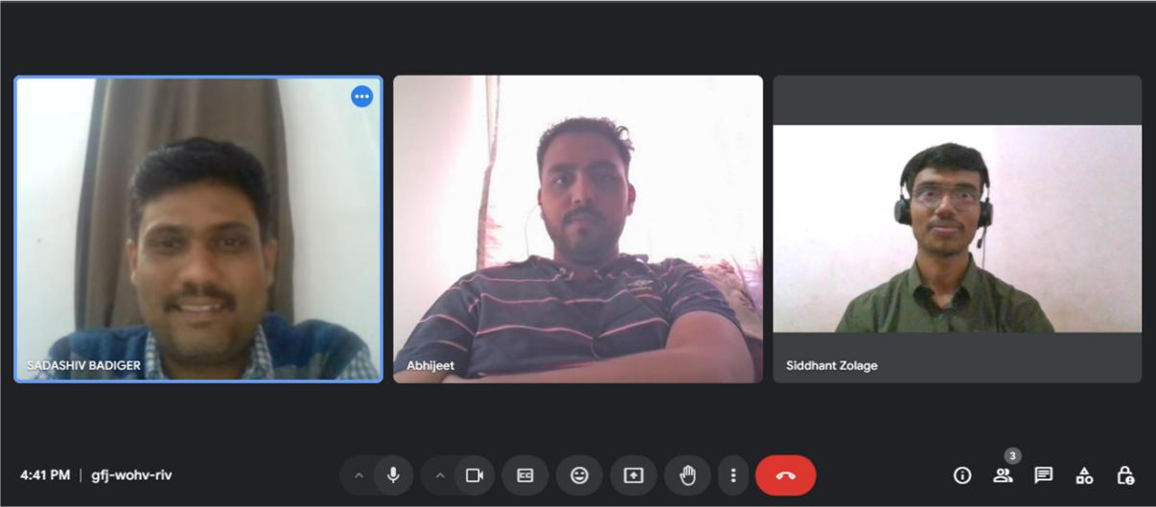

1. **IMAGES**

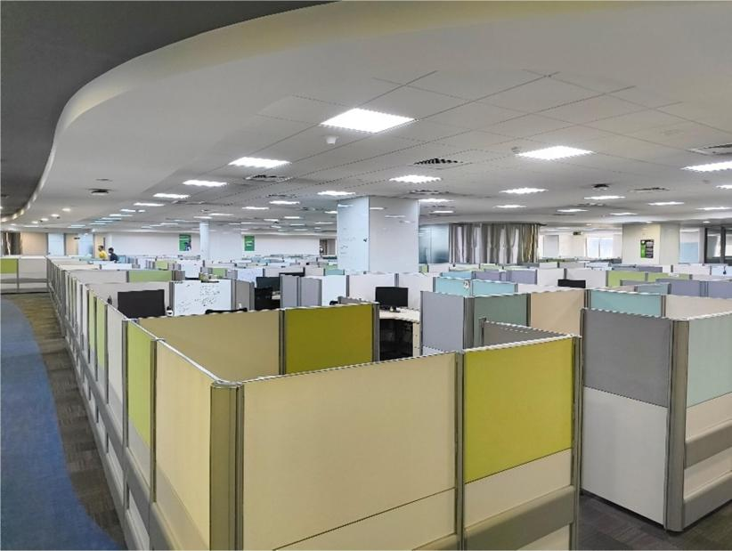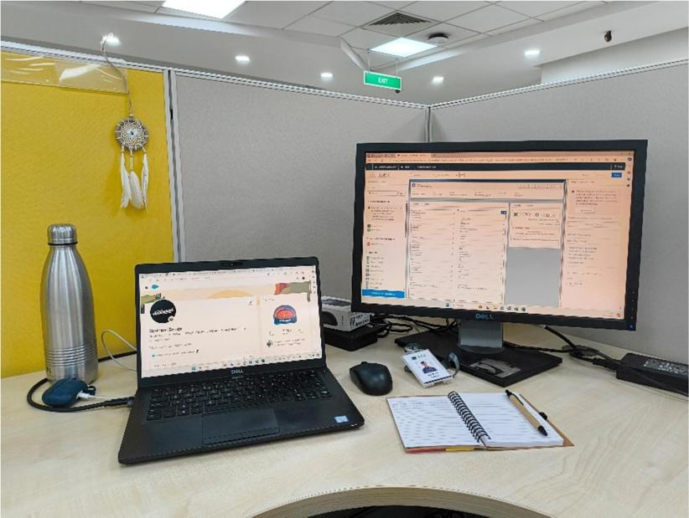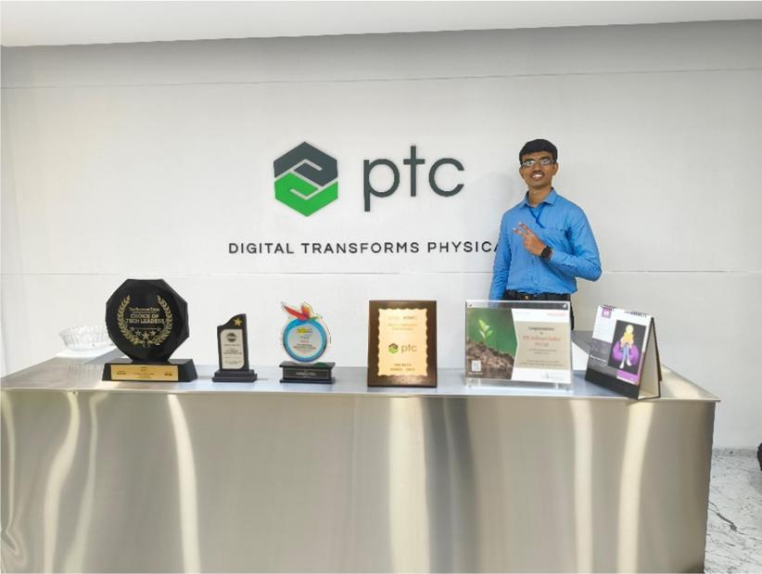

**INTERNSHIP OFFER LETTER**

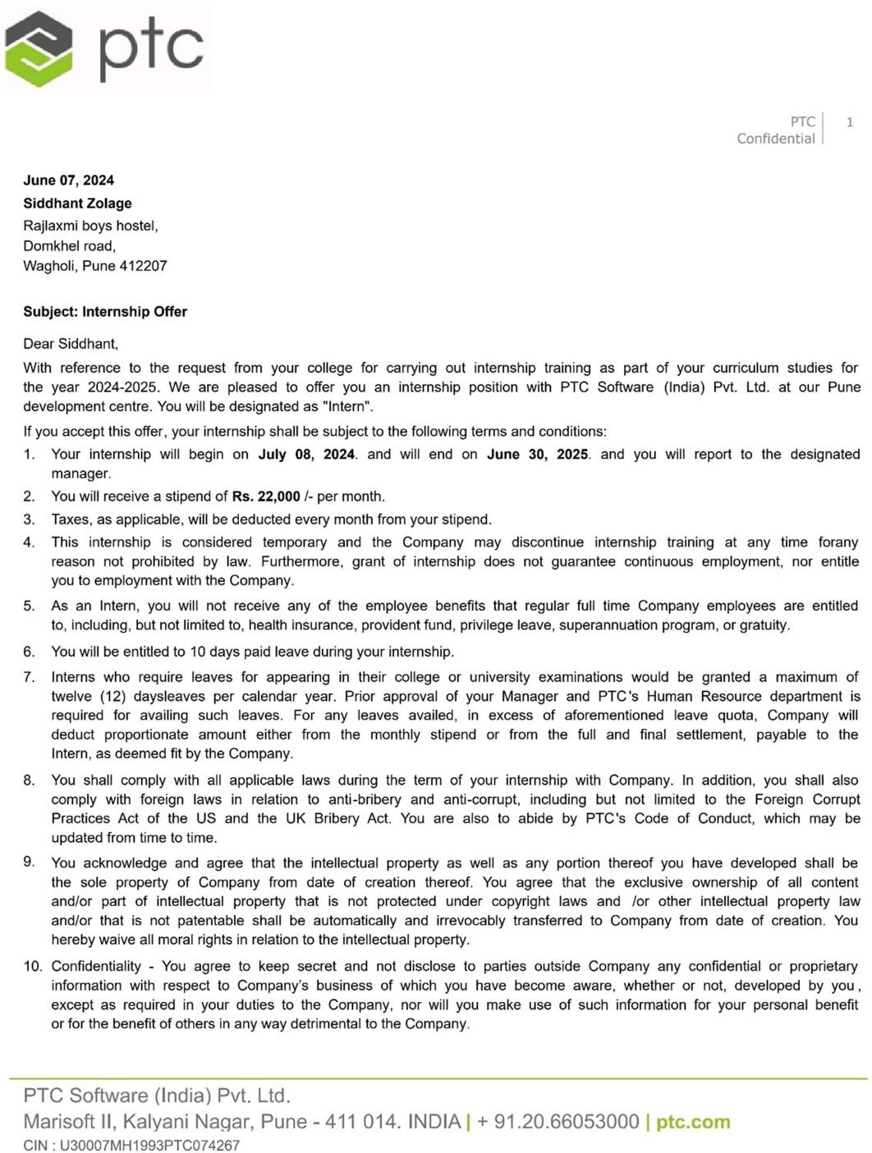

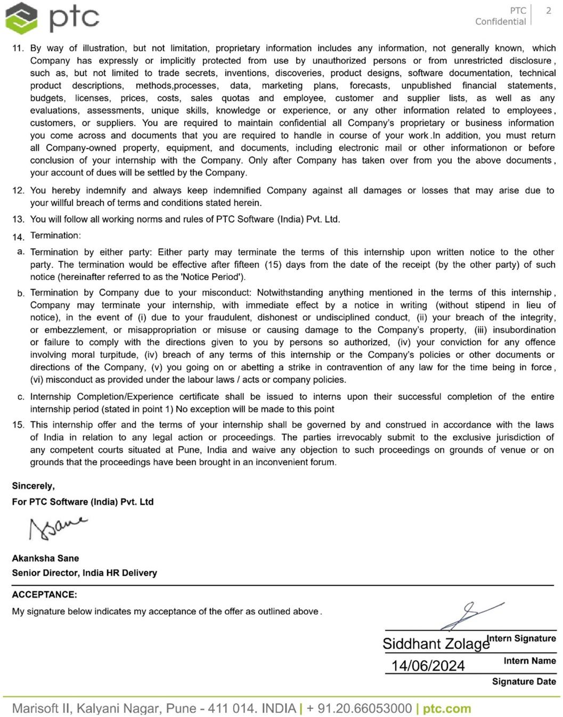

**INDUSTRY FEEDBACK FORM**

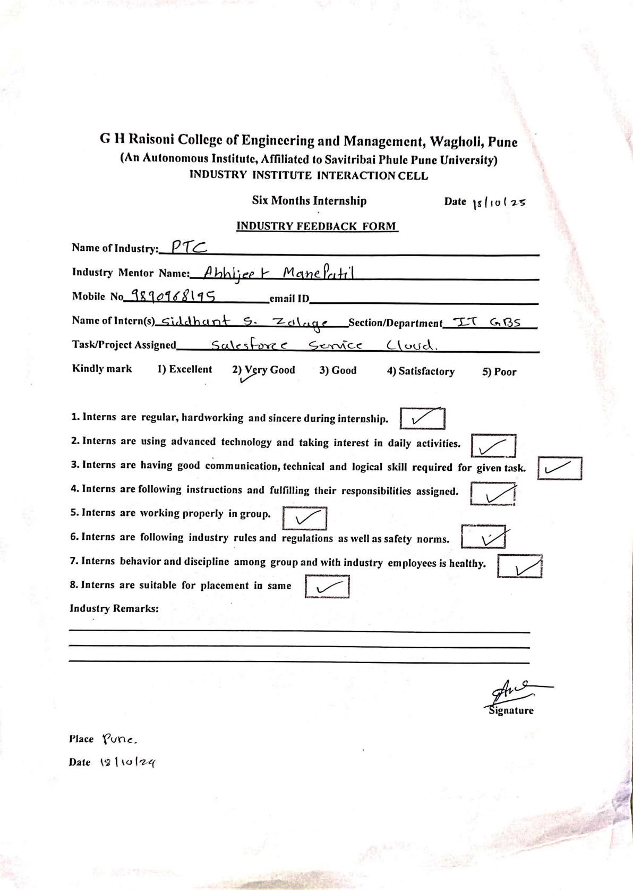

**NPTEL CERTIFICATE**

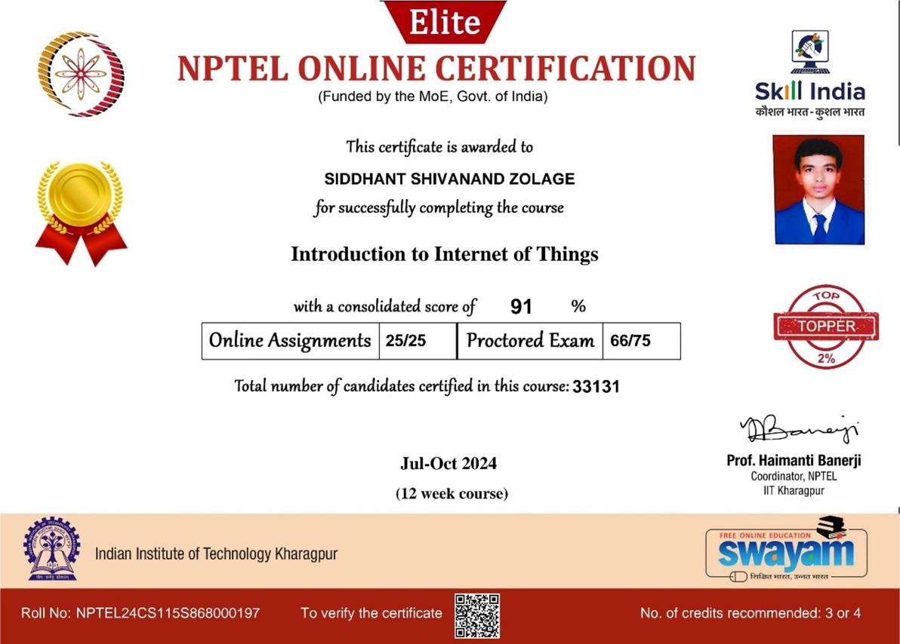

**6 MONTH INTERNSHIP CERTIFICATE**